UNIFIED MODELING LANGUAGE DIAGRAMS
  - The unified modeling language allows the software engineer to express an analysis model using the modeling notation that is governed by a set of syntactic semantic and pragmatic rules.
  - A UML system is represented using five different views that describe the system from distinctly different perspective. Each view is defined by a set of diagram, which is as follows.
  - User Model View
    - This view represents the system from the users perspective.
    - The analysis representation describes a usage scenario from the end-users perspective.
Structural model view
◆ In this model the data and functionality are arrived from inside the system.
◆ This model view models the static structures.
Behavioral Model View
◆ It represents the dynamic of behavioral as parts of the system, depicting the interactions of collection between various structural elements described in the user model and structural model view.
Implementation Model View
  - In this the structural and behavioral as parts of the system are represented as they are to be built.
Environmental Model View
In this the structural and behavioral aspects of the environment in which the system is to be implemented are represented.
UML is specifically constructed through two different domains they are
- UML Analysis modeling, which focuses on the user model and structural model views of the system.
- UML design modeling, which focuses on the behavioral modeling, implementation modeling and environmental model views.

Use case Diagrams represent the functionality of the system from a user’s point of view. Use cases are used during requirements elicitation and analysis to represent the functionality of the system. Use cases focus on the behavior of the system from external point of view.

Actors are external entities that interact with the system. Examples of actors include users like administrator, bank customer …etc., or another system like central database.

Use case Model

SYSTEM NAME

Use case 1

Use case 2

Use case n

Actor
Actor

USECASE FOR LOGIN

Login
DATABASE

USECASE FOR ADMIN

Home Page

Login Page

Admin Home Page

Add / Delete/Update Country

Add / Delete/Update State

Add / Delete/Update Industry Type
Admin

Add / Delete/Update Intrest

View/ Delete/Update User Info

View User Login/Logout Detail

Generate Reports of Registered Members

Print/Export Reports

USECASE FOR REGISTERED USER

Home Page

View/Update his Detail

View his Inbox

Send and Receive Mails

Change his Password

View Addressbook
User

Add/Update/Delete Contact

View Appointments

Add/Update/Delete Appointments

Use case name | Login
Participating actors | Admin, User.
Flow of events | The Actor will give the user name and password to the system. The system will verify the authentication.
Entry Condition | The actor will enter the system by using username and password
Exit condition | If un authenticated should be exited
Quality Requirements | Password must satisfy the complexity requirements.

Use case name | Admin Registration
Participating actors | Admin
Flow of events | The Admin will submit all the details and place in the application.
Entry Condition | Must satisfy all the norms given by the Employee Performance interface site.
Exit condition | Successful or Un successful completion of creation of account.
Quality Requirements | All fields are mandatory.

Use case name | User Registration
Participating actors | User
Flow of events | The user must enter all his personal details.
Entry Condition | View Home page
Exit condition | Registered User should be successfully logged out. Error Message should be displayed on Un successful creation.
Quality Requirements | Best Error Handling techniques. Check on Mandatory fields.

SEQUENCE DIAGRAMS

Sequence Diagrams Represent the objects participating the interaction horizontally and time vertically.

SEQUENCE DIAGRAM 1

Time
Admin
Home Page
Database
Admin Home Page
Use URL
Press login button
If Yes Goes to its Home Page
If No Come Back to Home Page
Validate if NO

SEQUENCE DIAGRAM 2

Home Page
Database
User Home Page

User

Use URL
Press login button

Validate if NO
If No Come Back to Home Page

If Yes Goes to its Home Page

Time

SEQUENCE DIAGRAM 3

Home Page
Database
Registration Page

New User Registration

Use URL
Press button

Validate if NO

After registration login to the application

Homepage
Login Page
Home Page
User
Use URL
Press Login Button
If Yes Goes to Home Page
Validate If NOT
Come Back to Login Page
View All Mail Inbox

Database
Inbox
Click on Link for Inbox
Press link for see inbox
if Validation NOT OK
Back to Home Page
If OK Then go to Inbox Page

Time

SEQUENCE DIAGRAM FOR VIEW REGISTERED USER

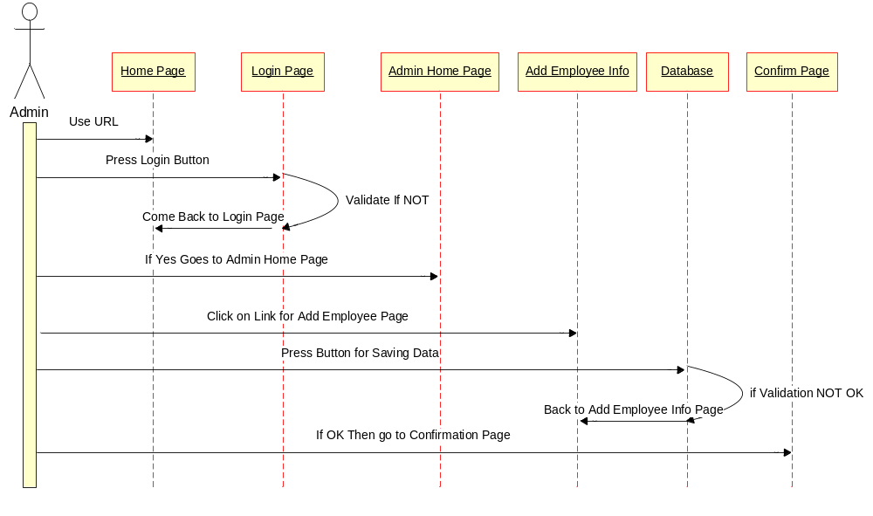

SEQUENCE DIAGRAM FOR VIEW REGISTERED MEMBER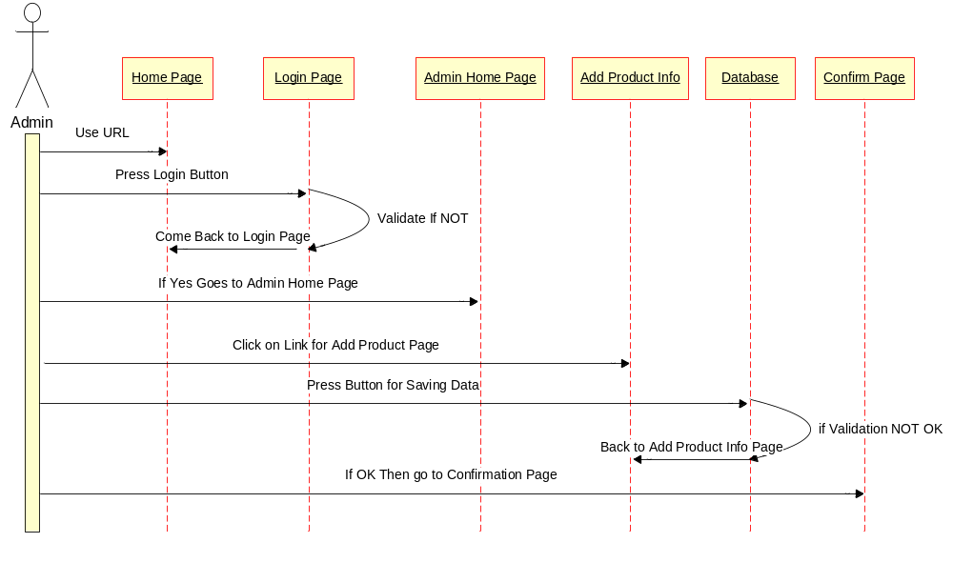

SEQUENCE DIAGRAM FOR USER

Homepage
Login Page
Home Page
User
Use URL
Press Login Button
If Yes Goes to Home Page
Validate If NOT
Come Back to Login Page
View All Contact

Database
Addressbook
Click on Link for Addressbook
Press link for see Conatct
if Validation NOT OK
Back to Home Page
If OK Then go to Addressbook Page
Homepage
Login Page
Home Page
User
Use URL
Press Login Button
If Yes Goes to Home Page
Validate If NOT
Come Back to Login Page
View All Mail Inbox

Database
Inbox
Click on Link for Inbox
Press link for see inbox
if Validation NOT OK
Back to Home Page
If OK Then go to Inbox Page
Homepage
Login Page
Home Page
User
Use URL
Press Login Button
If Yes Goes to Home Page
Validate If NOT
Come Back to Login Page
View All Contact

Database
Addressbook
Click on Link for Addressbook
Press link for see Conatct
if Validation NOT OK
Back to Home Page
If OK Then go to Addressbook Page

